

Swinburne University of Technology
Lab02
REPORT
Applied Machine Learning - COS30082
Student Name: Truong Ngoc Gia Hieu
Student ID (VietNam): SWS01217
StudentID (Australia): 105565520

Logistic Regression Model
In the second laboratory of the unit, the task requires students to utilize two models including Logistic Regression and SVM Model to predict Titanic survival. In the first section of the document, I use the Logistic Regression Model to predict whether passengers survived or not based on their personal attributes such as age, gender, and ticket class.
First and foremost, I need to load the dataset named Titanic-Dataset.csv and print first five rows of the dataset.
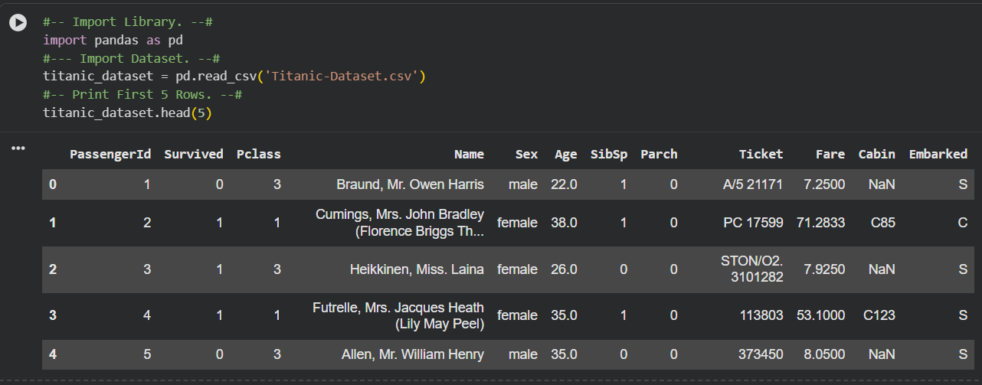
Figure 1: Overview of the Titanic Raw Dataset.
Next, I use the following method to showcase crucial information:
- .info(): Displays column names, non-null value counts, and the data types of each column.
- .describe(): Showcases statistical summary of the dataset.
- .isnull().sum(): Counts the total number of missing (null) values for each column.
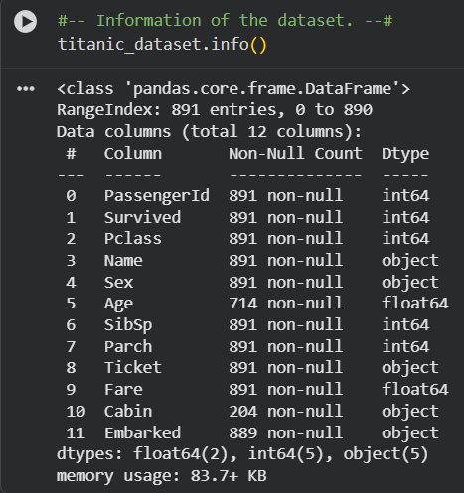

Figure 2: Dataset Structure and Data Types Overview
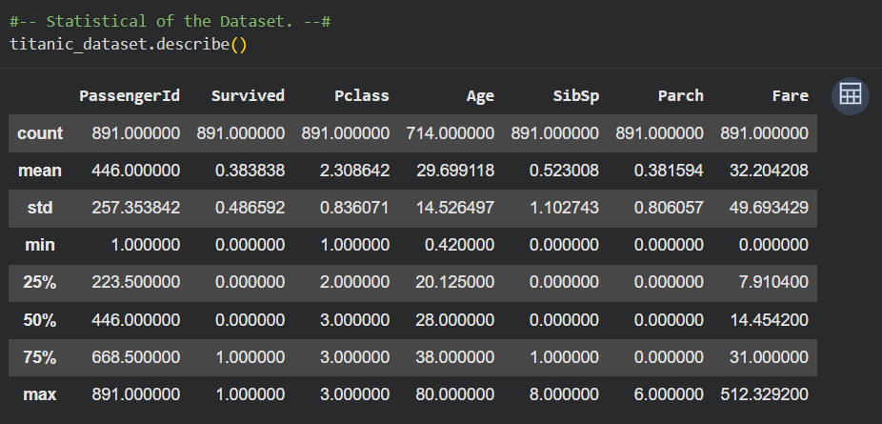
Figure 3: Statistical Summary of the Dataset
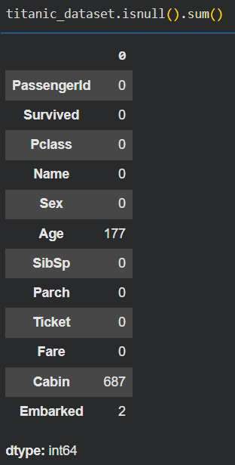
Figure 4: Missing Values Count per Feature

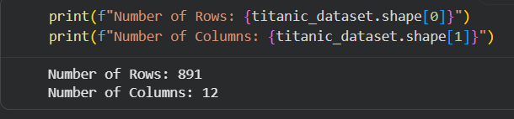
Figure 5: Total Number of Rows and Columns
After checking the number of null values, there are about 177 null values in the feature Age, 2 values in the Embarked column and 687 values in the Cabin feature. From my perspective, I suggest using the median method in terms of filling missing age values, as it is robust against outliers and provides a stable central tendency. Meanwhile, because the Cabin column is the categorical data type so in this case, I decide to make a new group named Unknown group. Notably, the reason why I do not delete because number of missing value is large which is 687 out of 903 dataset.
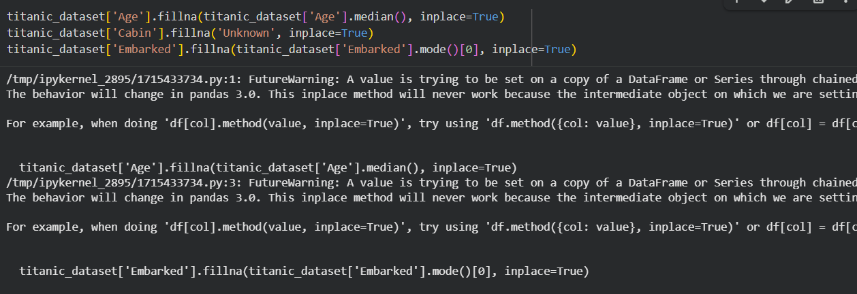
Figure 6: Handling Missing Values for Age and Cabin Features

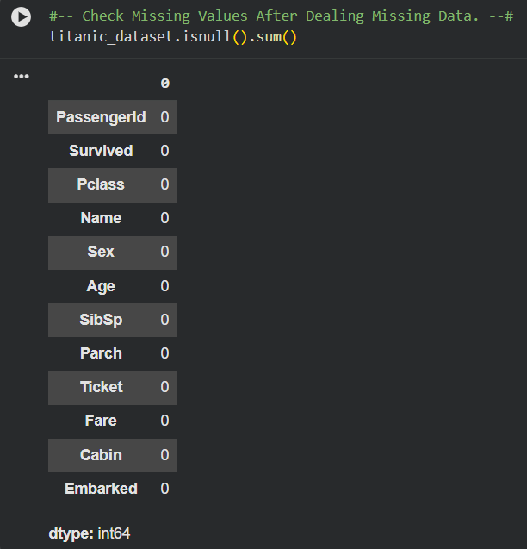
Figure 7: Verification of Missing Values After Imputation
Subsequently, because both Logistic Regression and SVM models cannot understand text data such as gender categories and embarked ports, these categorical features must be encoded into numerical representations. In detail, I drop out column Ticket because it is not necessary for prediction, encode column Sex (0 for male and 1 for female), and One-Hot Encoding technique for Embarked and Cabin feature.
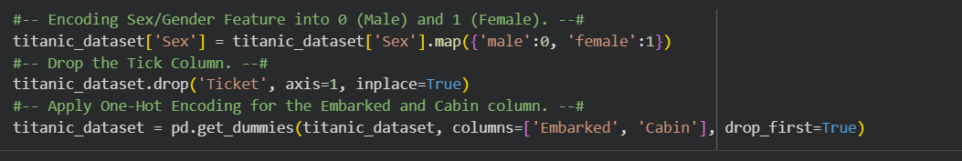
Figure 8: Categorical Encoding for Categorical Features
Based on the requirement of the lab, the target variable was defined as Survived while the remaining columns were used as input features for prediction.

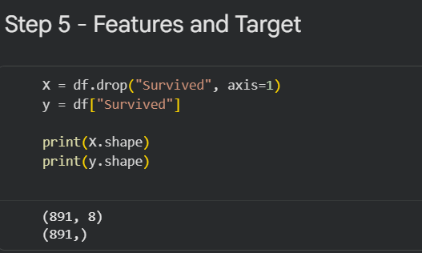

Figure 9: Separation of Features and Target Variable
In addition, the dataset was then divided into training and testing sets using an 80:20 ratio. The training set was used to train the models while the testing set was reserved for evaluating their performance on unseen data.
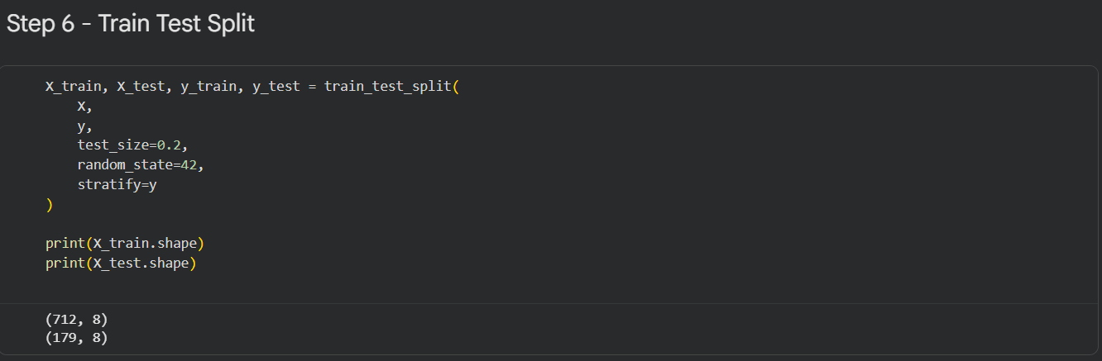
Figure 10: Train-Test Split and Data Dimensionality
Therefore, for ensuring reproducibility of the experiment, a fixed random state was applied during the splitting process. Furthermore, feature scaling was performed using the StandardScaler technique.
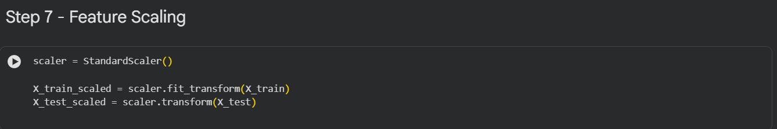
Figure 11: Feature Scaling using StandardScaler

After import dataset, exploratory data, choose feature and split into train and test part, I move to training dataset with Logistic Regression and SVM Model.
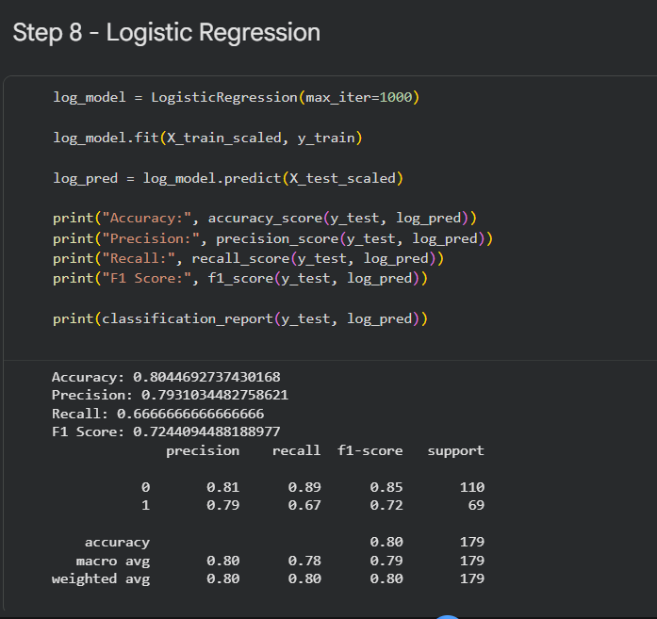
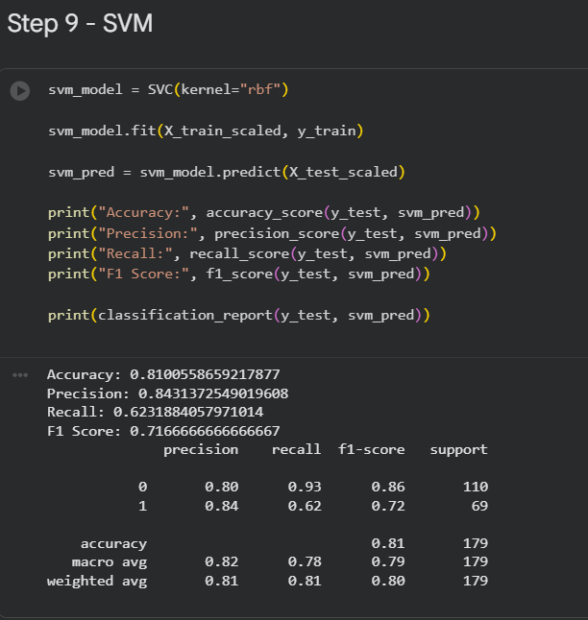
Figure 12: Logistic Regression Model Training and Evaluation Metrics

Figure 13: Support Vector Machine (SVM) Model Training and Evaluation Metrics
After that, I compare accuracy between Logistic Regression and SVM.
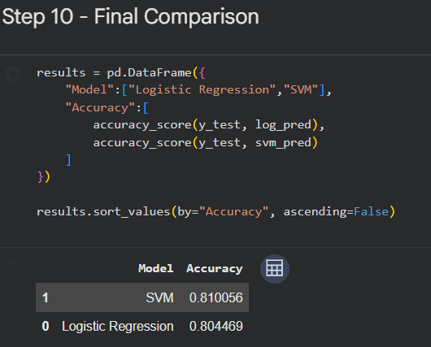
Figure 14: Final Model Performance Comparison (Logistic Regression and SVM)

